|  |  |
| --- | --- |
| Name | Maria Basharit |
| Ag# | 2018-ag-1663 |
| section | A |
| Github | https://github.com/mariabasharat/maria.git |

Q1. Place the screenshot of CMD or Gitbash showing the version of your Java complier in the assignment file in your shared Dropbox folder.

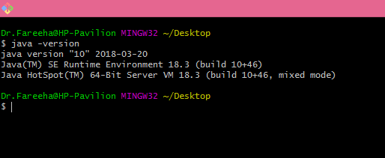

Q2. Place the screenshot of CMD or Gitbash showing the version of your git in the assignment file in your shared Dropbox folder.

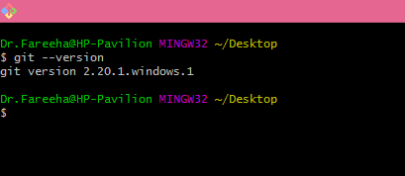

Q3. Place the screenshot of CMD or Gitbash after running **git status** command in the assignment file in your shared Dropbox folder.

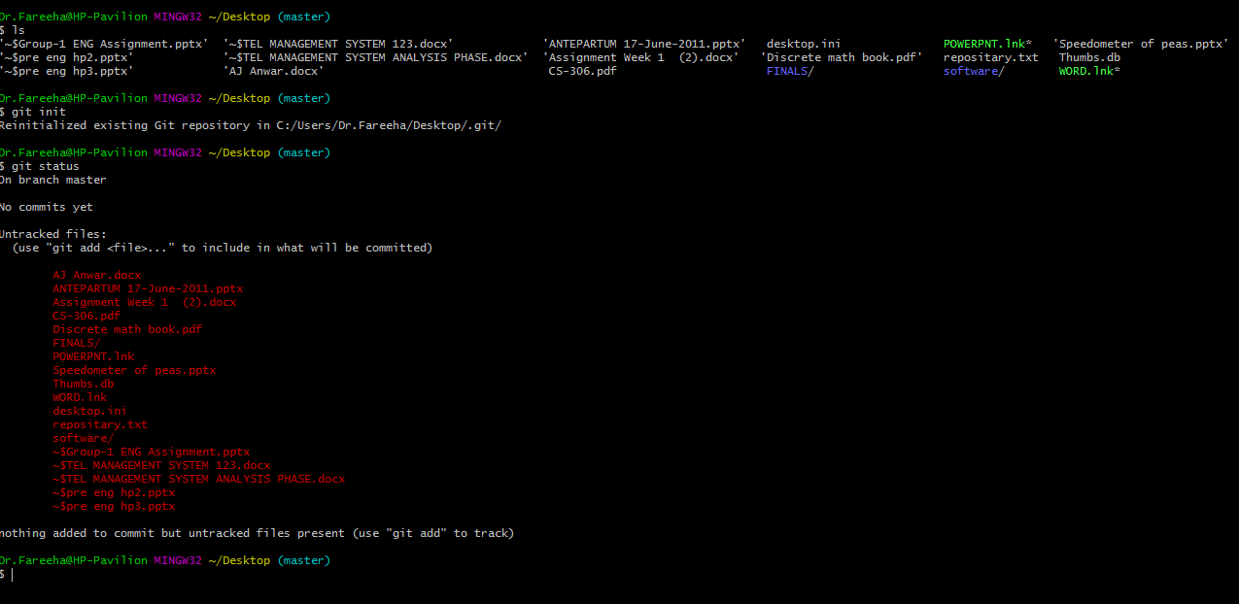

Q5. Execute the code step by step on your note book and past the pictures of it in the assignment file in your shared Dropbox folder.

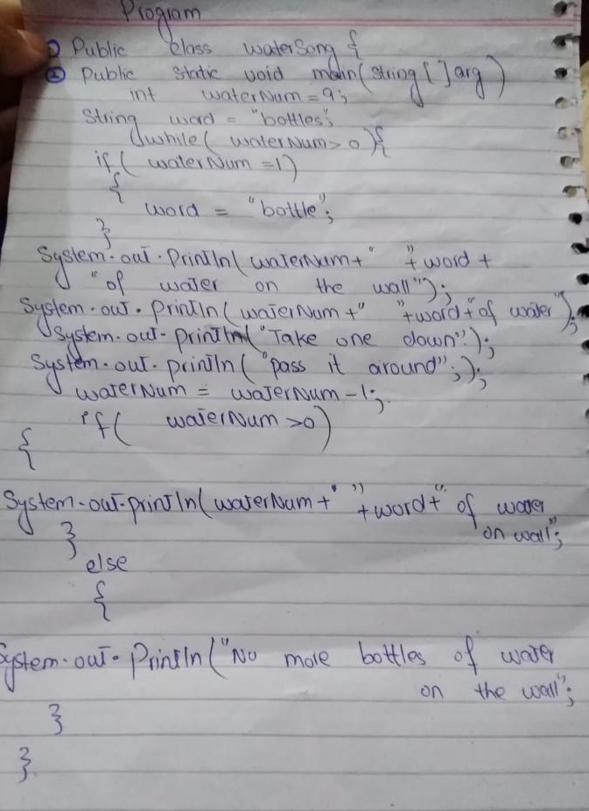

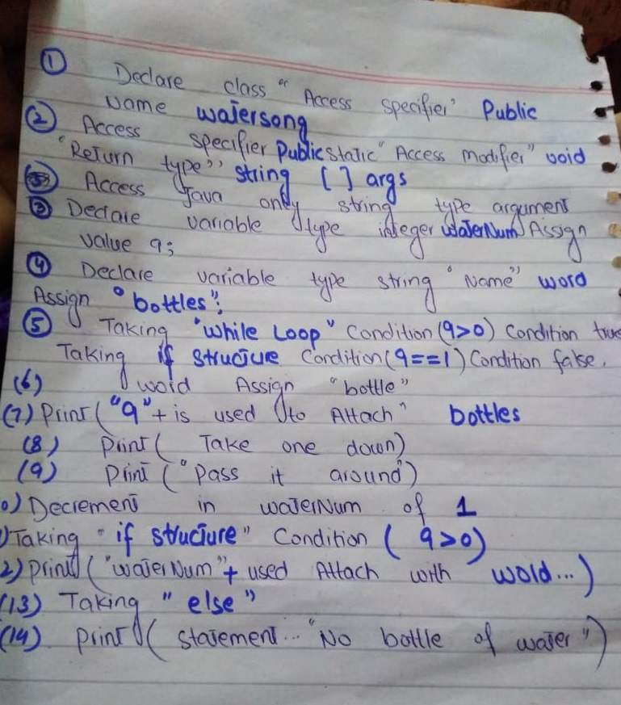

Q6. Run and compile the code. Upload it on the GitHub.

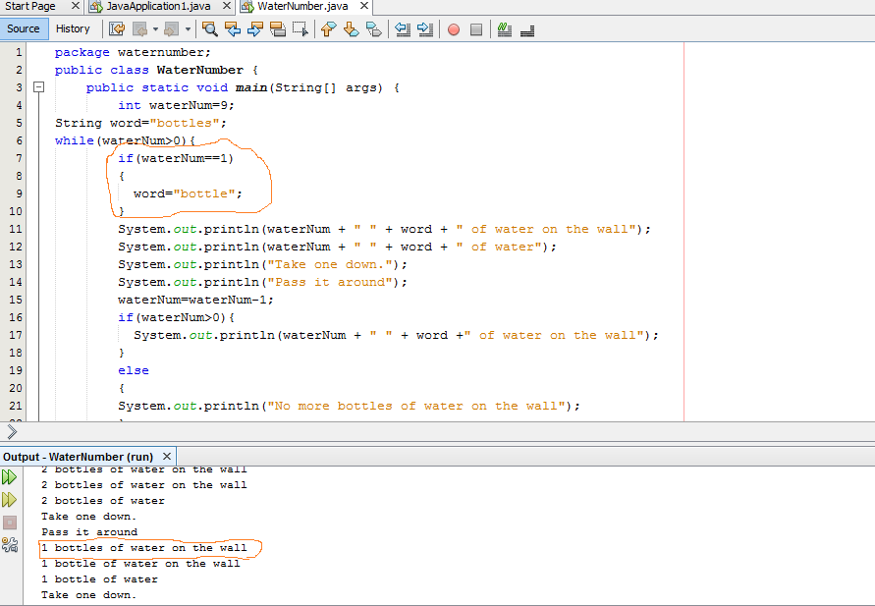

Q7. Upload WaterSongFixed on the GitHub.